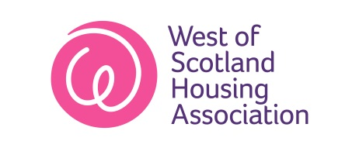
Housing Officer Information
South Lanarkshire | North Lanarkshire/  Glasgow North | South Lanarkshire/  Glasgow West | North Lanarkshire/  Glasgow North
Blackwood Lanark  Uddingston  East Kilbride  Law  Kirkfieldbank  Stonehouse  Kirkmuirhill  Strathaven | Cumbernauld  Kilsyth  Moodiesburn  Queenzieburn  Springburn  (Keppochhill Rd) | Blantyre  Westcraigs  Fernhill  Halfway  Hamilton  Hillhead  Glasgow West dispersed  Glasgow N/E dispersed | Airdrie Auchentoshan  Bellshill  Motherwell  Coatbridge  Royston  Springburn  (excluding Keppochhill Rd)  The Point/Possil
Sharon Cowan  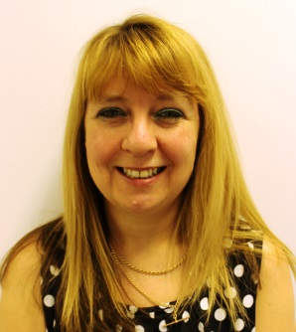 | Heather MacKenzie  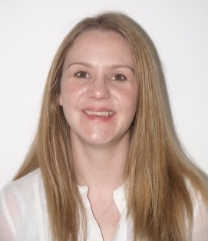 | Karen Wright  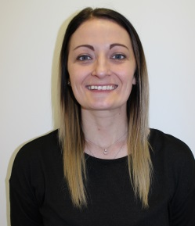 | Lynette Baillie  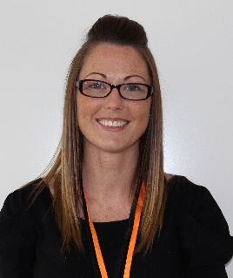
0141 550 5609 | 0141 550 5075 | 0141 550 5624 | 0141 550 5632

Ayrshire/  Glasgow | South Ayrshire | Glasgow  East/South | Glasgow  East
Troon  Kilmarnock  Irvine  Ardrossan  Yoker/Anniesland  Gallowgate | Ayr  Mossblown Prestwick  Symington Monkton | Camlachie  Pollokshields  Govan Rd  Govan/Elderpark  Crookston 36 | Camlachie Dalmarnock (Games Village)  Broomhouse  Barrachnie  Tollcross Easterhouse
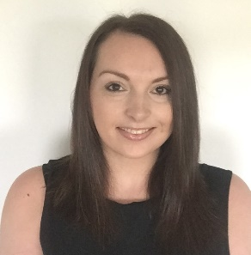  Jennifer Milligan | 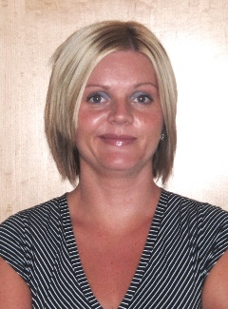  Susan Greenan | 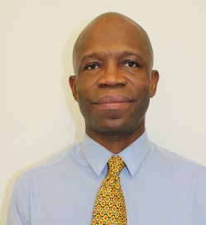  Yaw Frempong | Stuart Cole  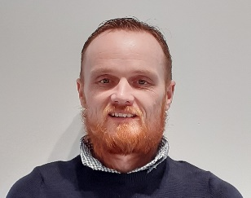
0141 550 5069 | 0141 550 5600 | 0141 550 5626 | 0141 550 5607

Income Maximisation Team Information

Ayrshire/  Glasgow | South Lanarkshire | Glasgow North/ North Lanarkshire | Glasgow  East/South
Ayr  Mossblown  Ardrossan  Prestwick  Monkton  Symington  Troon  Kilmarnock  Irvine  Yoker/Anniesland  Gallowgate | Blackwood  Lanark  Kirkfieldbank  Uddingston  Law  Stonehouse  East Kilbride  Kirkmuirhill  Strathaven  Westcraigs/  Blantyre  Halfway  Fernhill  Hamilton  Hillhead  Partick  Maryhill | North Lanarkshire Dispersed  Cumbernauld  Moodiesburn  Kilysth  Airdrie  Queenzieburn  Bellshill  Motherwell  Coatbridge  Royston  Authentoshan  Springburn  The Point/Possil | Camlachie  Dalmarnock (Games Village) Tollcross  Broomhouse  Barrachnie  Easterhouse  Pollokshields  Govan  Crookston
Irene Simpson  (Income Max Officer)  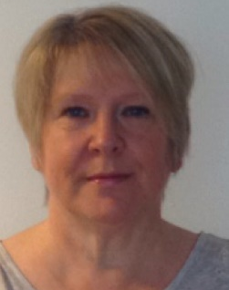 | Suzanne Quigley  (Income Max Officer)  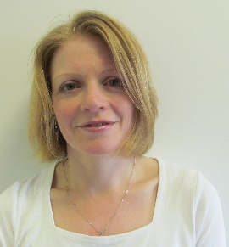 | Ashley Burns  (Income Max Officer)  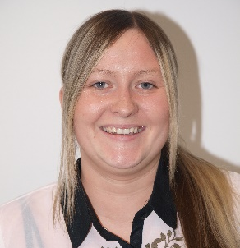 | Eileen MacDonald  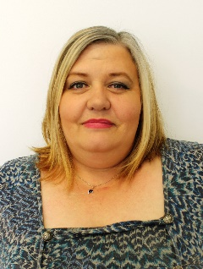  (Income Max Officer)
0141 550 5073 /  07827341971 | 0141 550 5647 /  07880 711 052 | 0141 550 5066 /  07899914398 | 0141 550 5055 / 07904429044
Irene Robertson  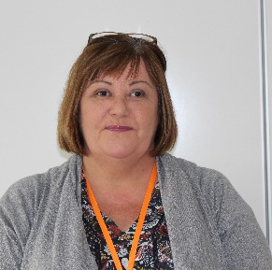  (Income Max Assistant) | Scott Angus  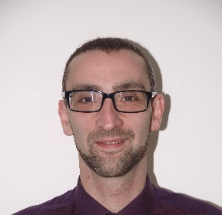  (Income Max Assistant)
0141 550 5633 / 07825 071038 | 0141 550 5054 / 07985 200087

